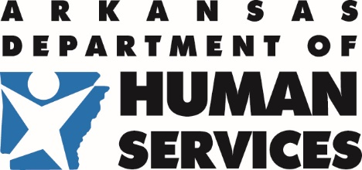 | Division of Aging, Adult, and Behavioral Health Services Office of Substance Abuse and Mental Health | 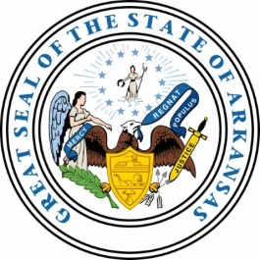
PO Box 1437, Slot W241 · Little Rock, AR 72203
501-686-9164 · Fax: 501-404-4614 · TDD: 501-686-9176

TO: Interested Parties

FROM: Jennifer Shuler, Assistant Director of Substance Use Prevention, Treatment and Recovery
Services, Office of Substance Abuse and Mental Health
Bridget Atkins, Clinical Director, Office of Substance Abuse and Mental Health

DATE: August 1, 2025

RE: Public Comment Period

Our Federal Fiscal Year 2026-2027 Mental Health and Substance Use Prevention, Treatment, and Recovery Block Grant Application has been posted on the Office of Substance Abuse and Mental Health Services webpage

The public comment period for this grant application is August 1, 2025 through August 17, 2025.

Copies of the application can be found here: https://humanservices.arkansas.gov/wp-content/uploads/DRAFT-FFY-2025-2026-SAMH-Application-for-Public-Comment.pdf .

Please forward all comments regarding this application to Teresa Belew via email to: Teresa.Belew@dhs.arkansas.gov . Comments will be accepted until 11:59pm on August 17, 2025.

